Week-4

**Activity 4.1. Complete the 30 mins activity of reflecting on the following questions:**

**Tasks that I have to complete urgently:**

|  |  |  |  |
| --- | --- | --- | --- |
| Module | Week | Task No | Due Date |
| CN4002 | Week-2 | Tutorial Question  10-15 Need answer | Week-2 |
| CN4002 | Week-3 | Tutorial question  1 need to complete | Week-3 |
| CN4002 | Week-3 | Lab practical questions 2-6 need to complete | Week-3 |
|  |  |  |  |
| CN4003 | Week-4 | Need to go through the lecture slides again to complete the lab task | Week4 |
| CN4005 | Week-4 | Target to finish on time | Week-4 |

**Tasks are important but not urgent.**

|  |  |  |  |
| --- | --- | --- | --- |
| Module | Week | Task No | Due Date |
| CN 4003 | Week-3 | Need to write the week activity in my word folder | Week-3- overdue |
| CN4005 | Week-4 | Target to finish today | On-time |
|  |  |  |  |

**Tasks are not important, not urgent, but  wish to complete:**

|  |  |  |  |
| --- | --- | --- | --- |
| Module | Week | Task No | Due Date |
| CN4002 | Previous weeks | Lecture slides and videos to revise | Whenever have time |
| CN4003 | Previous and coming weeks | Work on finalizing the assignment web page | In advance |
| CN4005 | Previous and coming weeks | Find time to work in advance rest of the task after 2 | In advance |

**Task 2:**

Individual Time Management Plan;

Due week 4, L.O. 1 & 5. 10%

(Individual) Students to create a comprehensive time management plan based on GTD. Students are allowed to use a different approach, provided it is an academically published approach, and they provide a citation of their source. The key aspect of this assessment is that the student has demonstrated good forward planning that covers academic tasks and deadlines, personal development deadlines, and day-to-day deadlines.

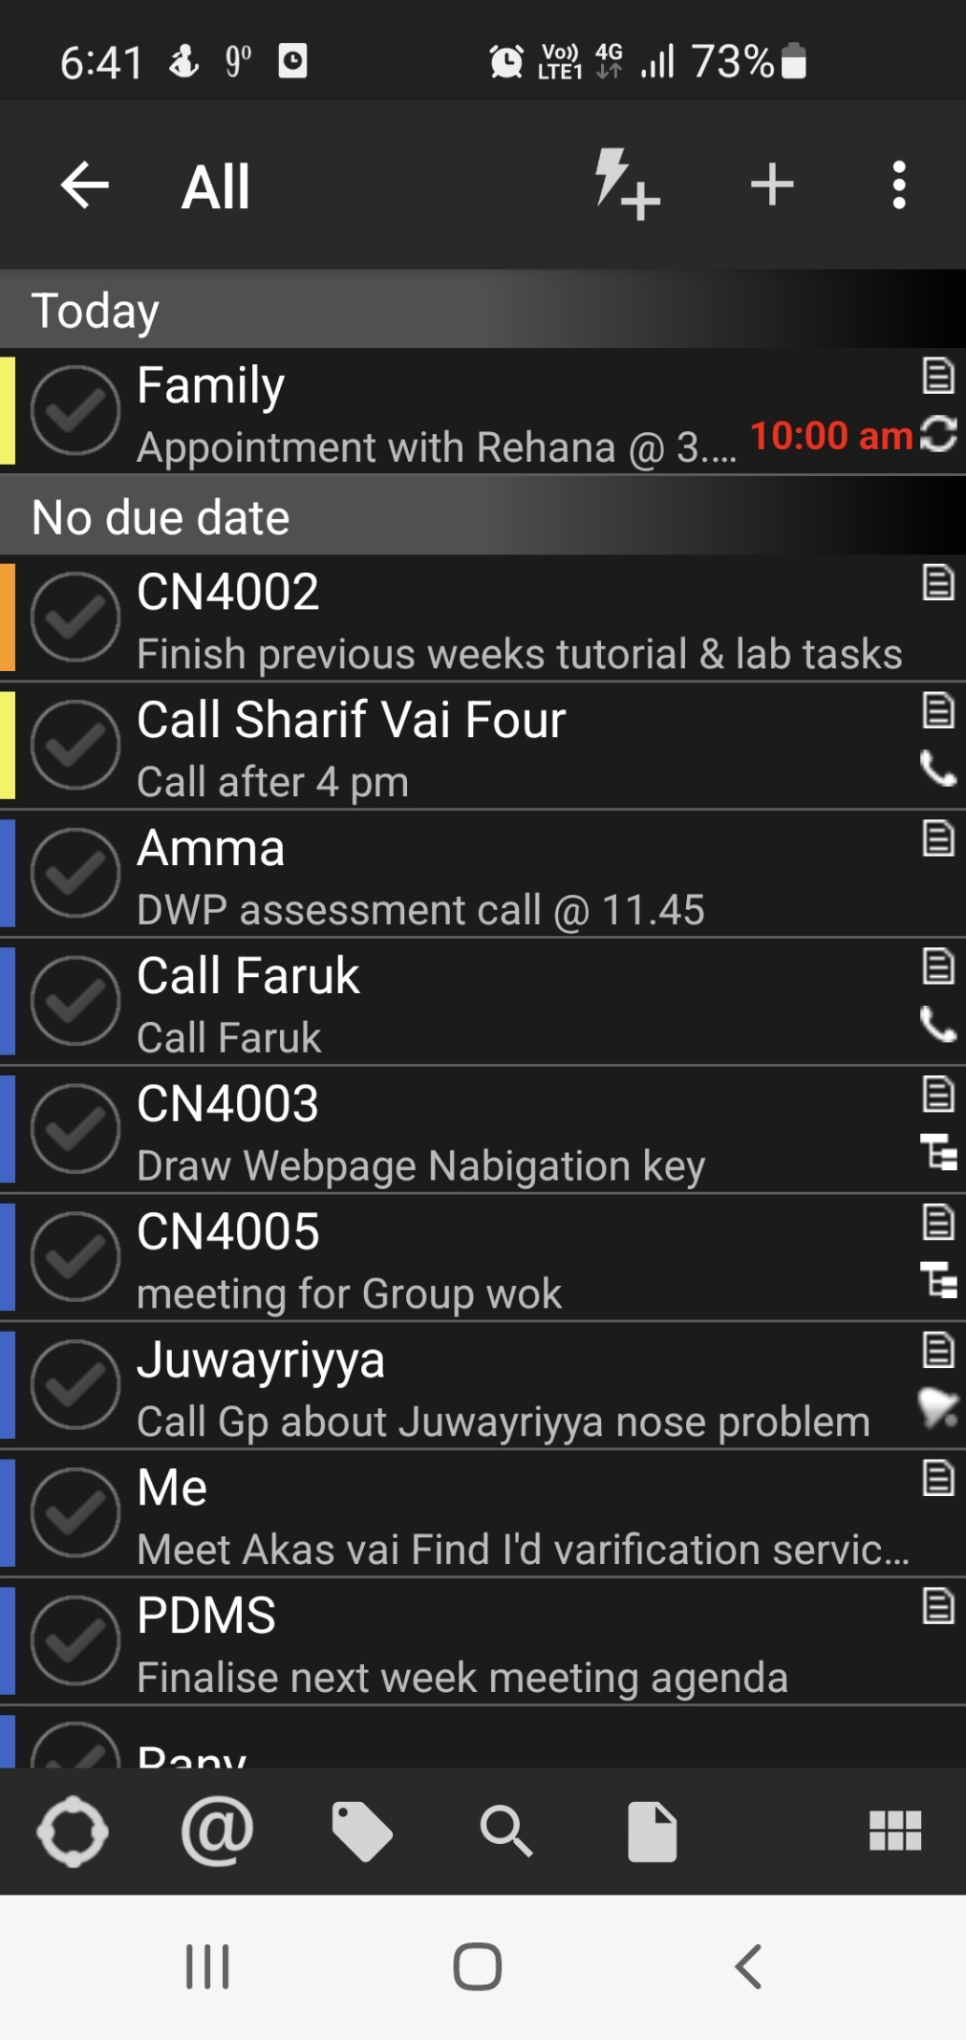

Task-3- Writing a Proposal: